**Instructions for joining the *Miss Virginia* Netflix Party:**   
  
Please note you do have to sign into your Netflix account, sign up for the FREE 30 Day trial or ask a friend to be added to their account. Access to a Netflix account is required.

Download the Google extension  
After everyone has signed up for Netflix or logged in on their computers, they'll need to download the Netflix Party extension. Here's how.  
  
1. Visit [netflixparty.com](https://l.facebook.com/l.php?u=http%3A%2F%2Fnetflixparty.com%2F%3Ffbclid%3DIwAR0Xi081oJZX2b5RSzGscJ41UDfatHDl42Eo9cRJScbot_WwbAsDnQIzm6Y&h=AT38kw9hPJFjuOHhwFIea7uec9bBnWf8A1Eo5cWhxpcQ-aSZP9j7YNAQCX2zc5OLrx3lm5ttFHK0bqXZw_SYypcYreZ1zS6HCgZ_Hl9Vwf7uf-G9b3sZvjhC9Ajbf0v_pmxGAqRxXYvIBGC_) on your Google Chrome browser.  (← yes, it must be Chrome.  Firefox, Internet Explorer, or another browser will not work.)

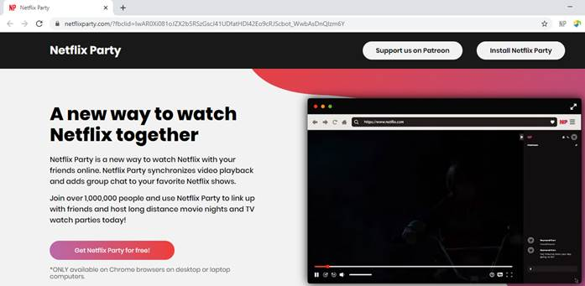  
  
2. Click Get Netflix Party for free.

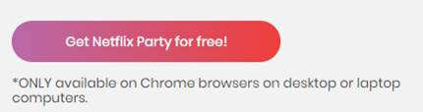  
  
3. You'll be redirected to the Google Chrome web store page to download the extension. Click Add to Chrome.

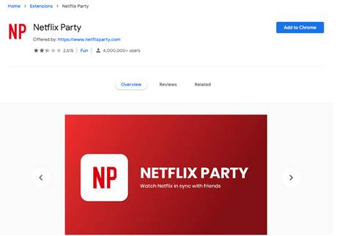  
  
4. A pop-up box will open. Select Add Extension. You'll now see a GREY “**NP**” icon in your browser bar. TOP RIGHT CORNER.

🡨 “**NP**” is on top far right corner next to your browser bar.

\***Now that you've got the extension downloaded, you can begin watching shows and movies with your friends and family. Here's how to get started.**\*

5.  Open the link:

Party Link will be posted on FaceBook and sent via email for guests who have registered at 2:15 CT on Saturday the 28th.

6. The “NP” on your toolbar should now be RED. You need to click the red NP once to join the group chat.  There should be a selected box that says “Show Chat”.  Click and the chat should appear. Say “Hello” to us and add your name!

7. Enjoy Movie and look for opportunity to win one of the 2 $100 Gift Cards!

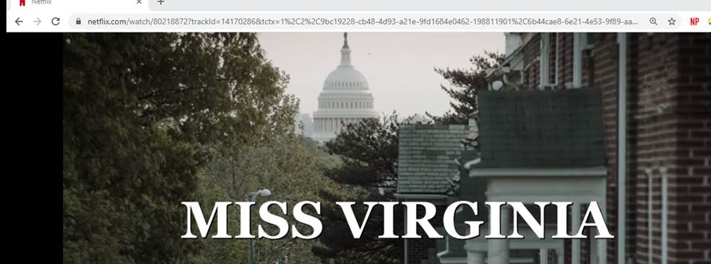 🡨 RED “NP”